Multiple Store Manager Documentation

*Process to set-up or run the project:*

1. Go to my github accout https://github.com/Dhan25
2. Click the Multiple Store Account folder.
3. Now click on the Green button with the text ‘Code’.
4. Then click here to copy the url Repository after that go back to Visual Studio.

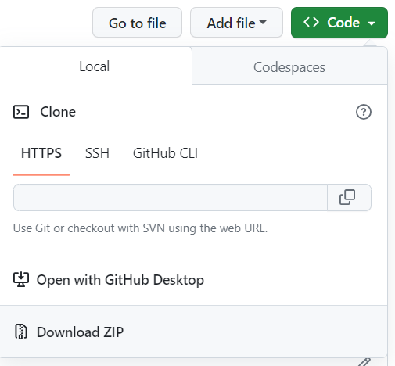

Link should be here

1. 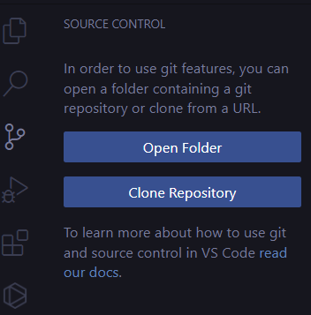Then click here
2. Now paste the url on the search box
3. Select the location/ folder where you want to store the files.

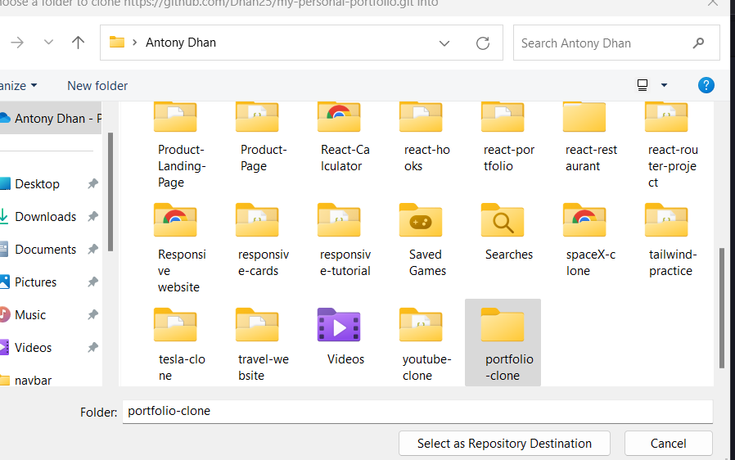

1. Now click open
2. 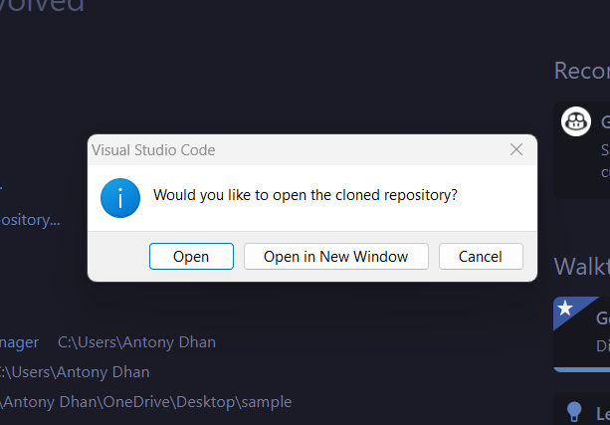Open your terminal in Visual Studio and type (npm run dev) to open it in the localhost.
3. 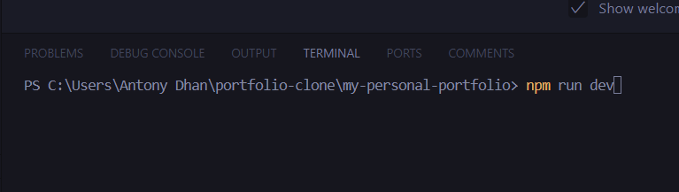Hold ctrl key then click to the localhost

